

30 Productions, One Promise: The Enduring Legacy Of Hamid Daudani And The Desi Stage
India-West News Desk
SAN DIEGO, CA – For thirty-five years, Hamid Daudani has been the quiet architect of Desi theater in San Diego, weaving cultural narratives into the fabric of the local arts scene. On April 18, that journey reached a poignant milestone at the Joan B. Kroc Theatre with the staging of ‘Tumne Waada Kiya Tha,’ the group’s 30th production. It was more than just a play; it was a celebration of a three-and-a-half-decade commitment to storytelling that bridges the gap between heritage and the contemporary immigrant experience.
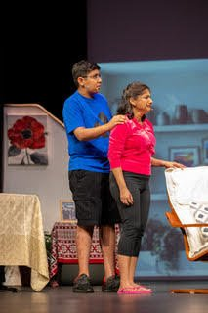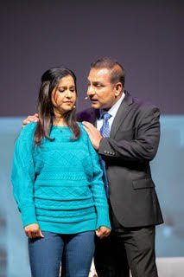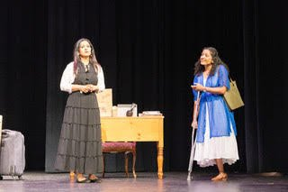
The production offered a compelling slice of life, inviting a full house to navigate the emotional peaks and valleys of a middle-class family. At the heart of this narrative were Paramita Datta Ghosh and Sachin Chawla, who portrayed Sumi and Shan with a nuanced confidence that anchored the evening. Their chemistry provided a steady pulse for the play, allowing the audience to feel the weight of their domestic triumphs and tribulations. This central gravity was lightened by Aarav Bhatia and Divya Bandyopadhyay, whose portrayals of the couple’s children, Asar and Aashi, captured the authentic, often humorous friction of sibling life.
True to the spirit of South Asian performance, the evening was a multisensory affair. Vivid dance sequences punctuated the drama with bursts of color and movement. During scene transitions, the audience was treated to musical interludes; a thoughtful touch that maintained the emotional atmosphere even as the sets changed.
Perhaps the most telling sign of the play’s success was the audience’s reaction. Cast members noted that viewers occasionally laughed during moments of high tension – not out of derision, but out of the uncomfortable, reflexive recognition of real life.
By mirroring the absurdity and the honesty of the human condition so closely, Daudani’s direction tapped into something universal.

